Name: _________________________________________________

What is:

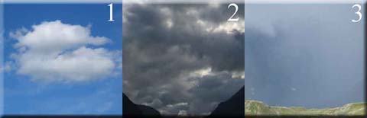

1 ____________________________________________________

2 ____________________________________________________

3 ____________________________________________________

4) What is Air Pressure?
____________________________________________________________________

____________________________________________________________________

____________________________________________________________________

5) How can you use the smoke from a campfire to predict a change in the weather?

6) What are some signs in nature that a storm is coming?

